User Guide
The username for the Log in is first name’s 3 letters and last name’s 3 letters.
This is not the finished version. It shows that the tiers communicate.

User guide-DRIVER
When the user (Driver) enters, first he sees is this widow:
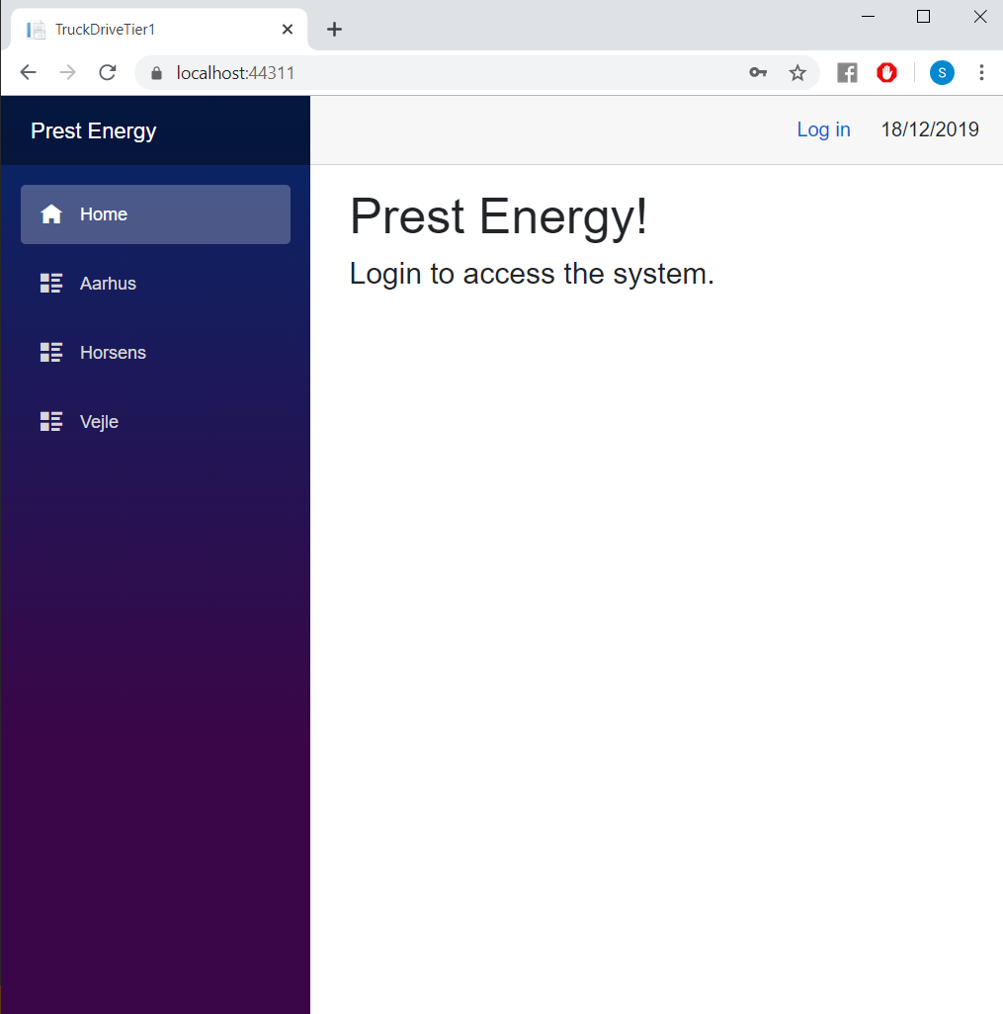
Image 1 Truck driver main page
You are not allowed to access any data without being logged in.
To log you must press the “Log in” button from the top right corner.
Image 2Truck driver how to login

Insert the username and the password in the text fields as in the picture below:
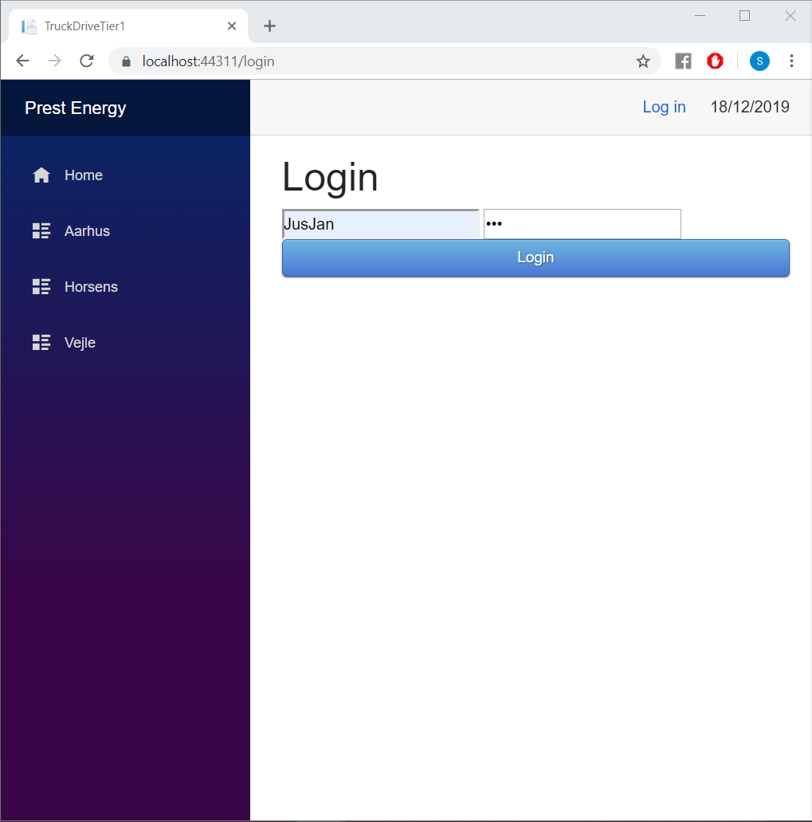
Image 3Truck driver login page

From the moment you logged in the system you are able to access different cities in order to know if there are customers or not.
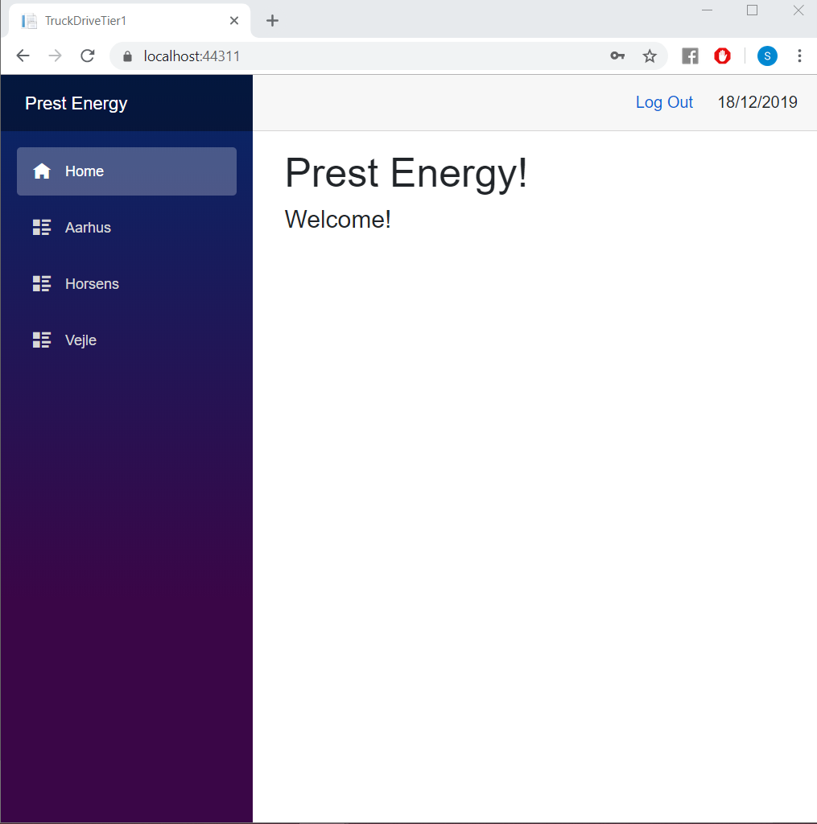
Image 4Truck driver nav menu

At the moment you chosen a city there will be displayed a list of the current clients in that city.
Look at the picture below:
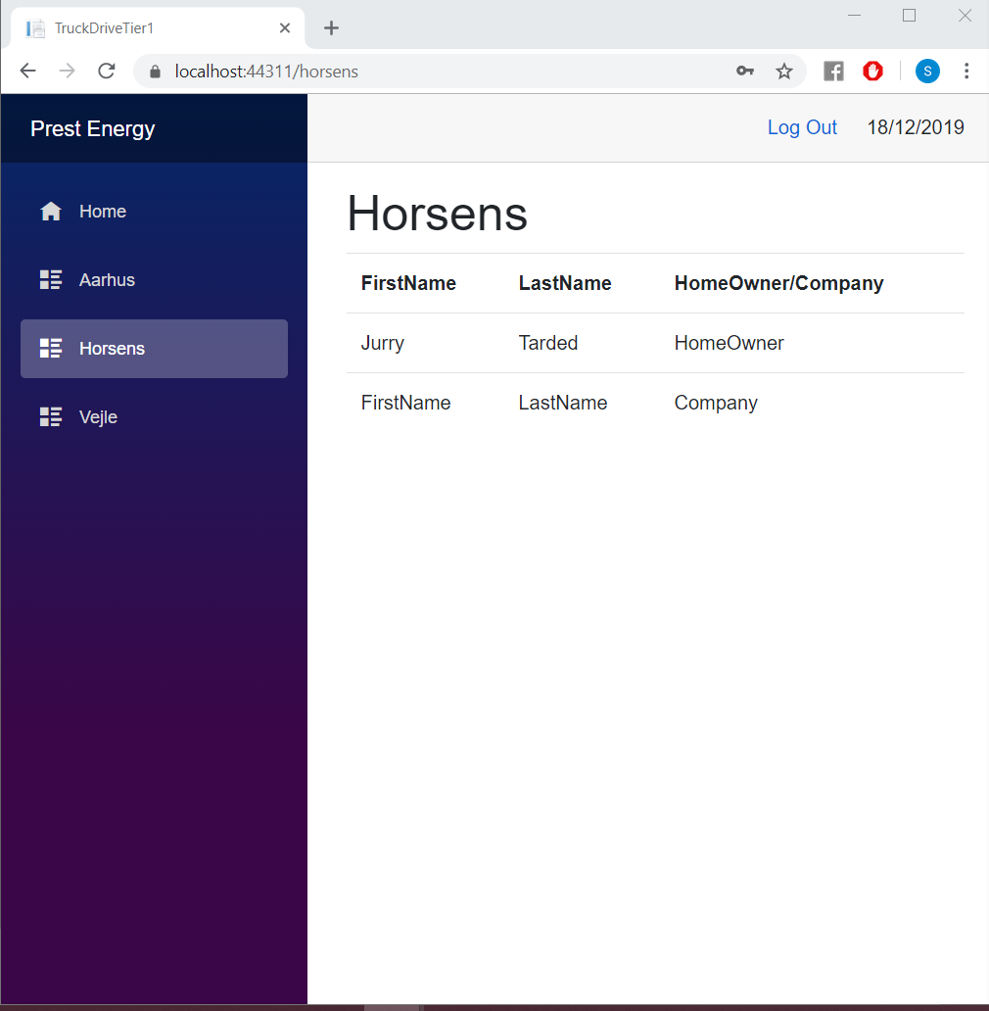
Image 5Truck driver city page with customers
For the city where are no client the view will look like this:

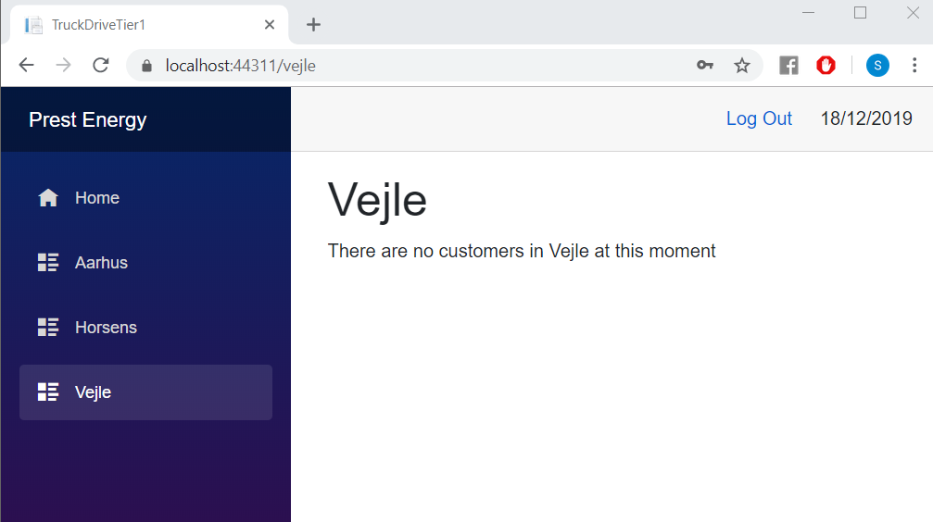
Image 6Truck driver city page without customers

User Guide-Client
The first thing you see is main page which welcomes you.
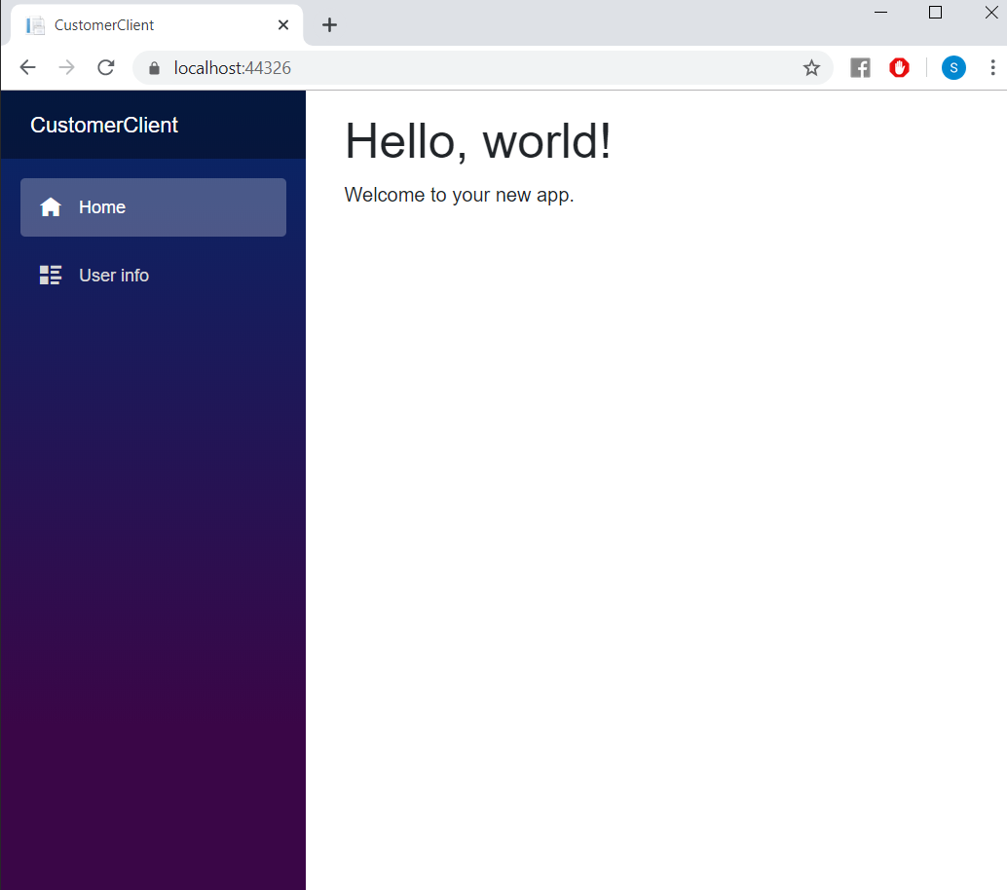
Image 7Customer view main page

As a client you are able to access - User info. There you can find information about users. To do this you have to press on User info button in the Navbar. As a result, list of all customers will appear.
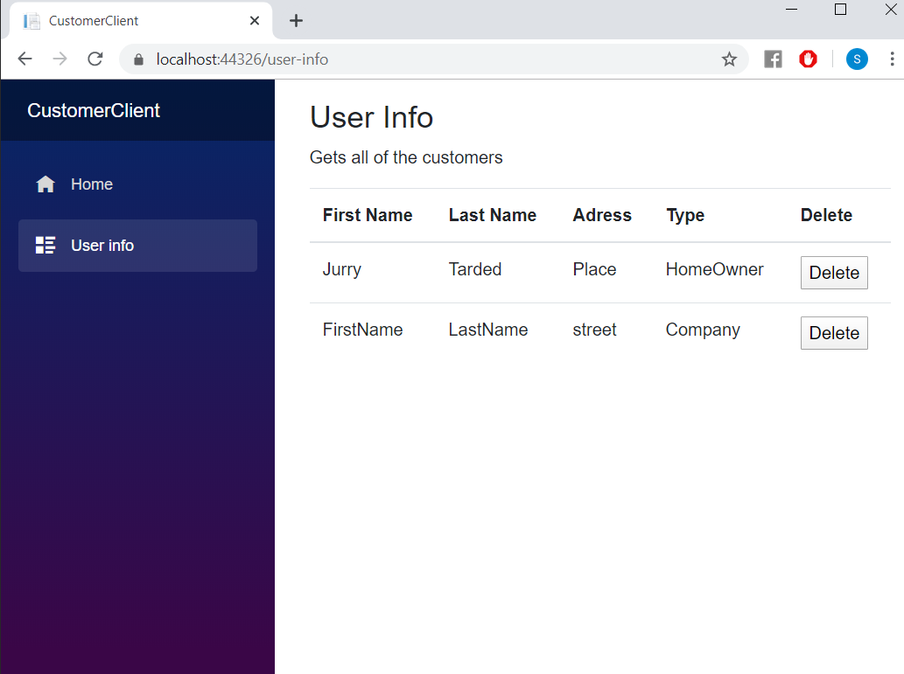
Image 8Customer view with all of the customers
You can delete the user by pressing the button “Delete” (This is made as a test thing to show the connections between tiers)
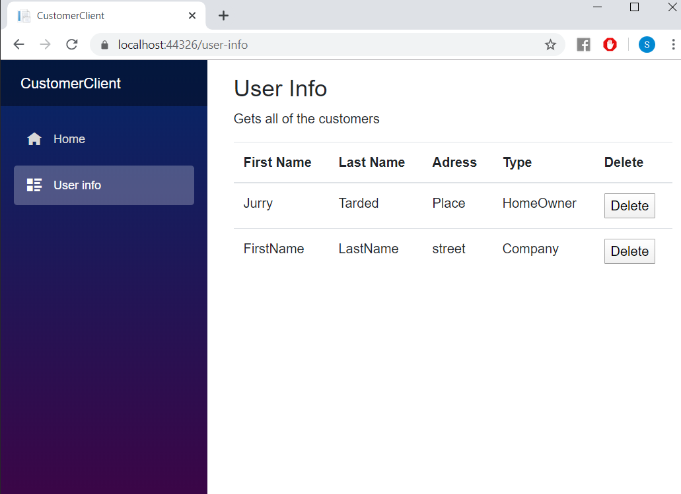
Image 9Customer view - delete customer

User Guide- Administrator
The first that you as administrator see is the List with all the clients and the Tab bar.
Tab bar shows you what are you allowed to do as administrator: Create new customer, Display Employees, create new employees and create new schedule. You can see it in the picture below.


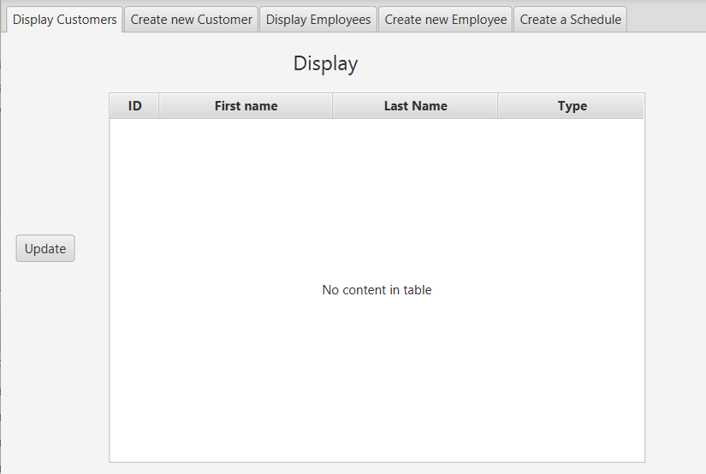
Image 10Administrator view - all tabs
To create new customer, you have to press on “Create new Customer” button.
After you have to fill out the credentials and press “Create” button.
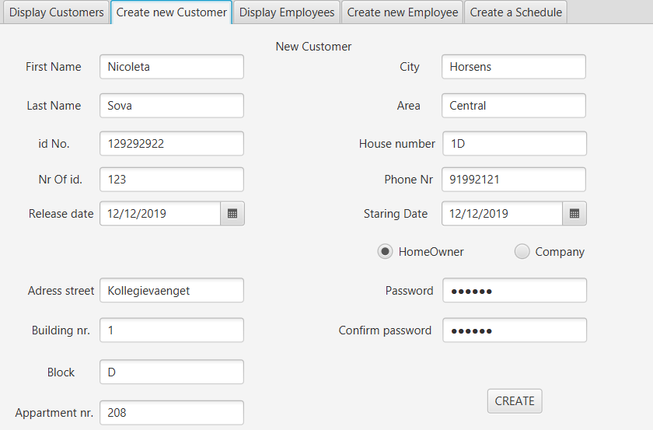
Image 11Administrator view - create new customer
To add new Employee, you have to press “Create new Employee” button, fill in the credentials and press “Add new Employee” button from the bottom.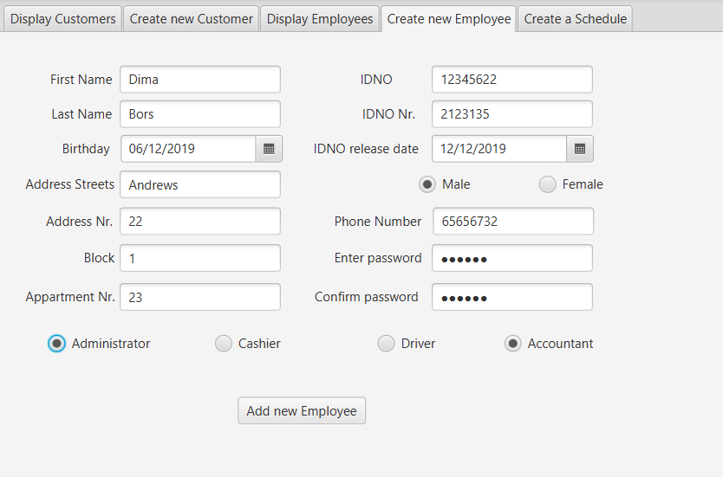
Image 12Customer view - create new employee

To create a schedule, you have to press “Create a Schedule” button from the top right corner. Fill in the form and press “Save” button.
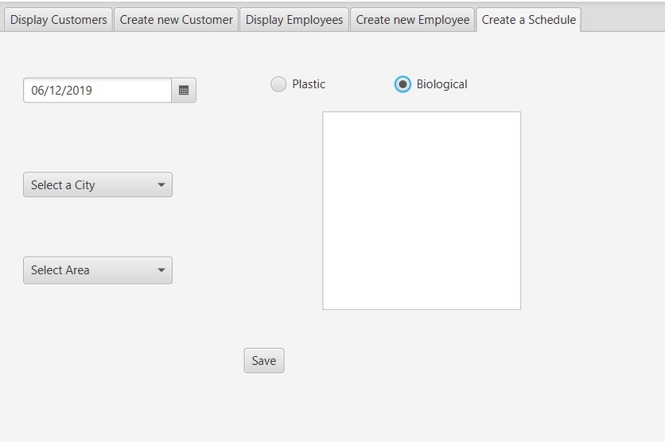
Image 13Customer view - create schedule

